

**AXPEX CONSTRUCTION COMPANY LTD**

***Building & Civil Engineering wisdom***

PROFILE

2022

ABOUT US

Axpex Construction Company Limited is a construction and infrastructural development company that came into existence in 2009. We are general contractors that undertake a variety of projects in buildings, water infrastructure, roads and civil works.

We bring together a plethora of professionals with requisite capacity, capability and outstanding track records in undertaking and managing major engineering projects.

We are currently operating in Kenya with prospect for greater Eastern Africa region. The company has successfully undertaken major projects across Kenya in the most diverse conditions and terrains over the last 11 years.

We take particular interest in the rehabilitation, refurbishment and maintenance of properties that are in our line of specialization as stated above and are always prepared for the said in all aspects.

OUR VISION

To be a world class construction company in the region and beyond for socio – economic advancement.

OUR MISSION

To creatively and innovatively construct safe, environmentally friendly and sustainable roads, buildings, water structures and any civil engineering works and services through optimal utilization of resources to the satisfaction of customers.

OUR CORE VALUES

### We believe in:

### Integrity

### Professionalism

### Teamwork

### Creativity

### Honesty and Accountability

### Environmental proactive

### **MOTTO**

### Building and Civil Engineering wisdom.

### **SPECIFIC OBJECTIVES**

1. To participate in the Engineering procurement, construction, rehabilitation, repair and maintenance of roads of all kinds.
2. To participate in the Engineering procurement, construction, rehabilitation, repair and maintenance of buildings of all kinds.
3. To participate in the Engineering procurement, construction, rehabilitation, repair and maintenance of water structures of all kinds.
4. To conduct road and building contracts business in a transparent and accountable manner.
5. To carry out civil engineering consultancy and work professionally and in accountable manner.
6. To partner with other firms involved in similar trades and products to provide wholesome building and civil engineering solutions to needy clients.
7. To create employment
8. To preserve environment
9. To bring new progressive culture into the construction industry in Kenya.
10. To embrace the use of information technology in the provision of building and civil engineering solutions to our clients.
11. To buy, sell, distribute, hire out and service new and second hand construction equipment.
12. To make, process, buy, sell and distribute building materials of all kinds.

**CERTIFICATIONS/ ACCREDITATIONS**

1. **INCORPORATION**

The company is incorporated as a Limited Liability Company in Kenya in January 2009.

1. **PERSONAL IDENTIFICATION NUMBER (PIN) REGISTRATION**

The company is registered by the Income Tax Department with PIN number.

1. **VALUE ADDED TAX (VAT) REGISTRATION**

The Company is a registered remitter of Value Added Tax with VAT number.

1. **TAX COMPLIANCE CERTIFICATION**

The company is certified by Kenya Revenue Authority as Tax compliant hence has a valid Tax Compliance Certificate.

1. **BUSINESS PERMIT**

The company has a Single Business Permit issued by City County of Nairobi and is valid until 31st December 2022.

1. **NATIONAL CONSTRUCTION AUTHORITY REGISTRATION**

* Registered Category NCA 5, Road and civil Engineering works by National Construction Authority.
* Registered Category NCA 5, Building works by National Construction Authority.
* Registered Category NCA 5, Dams and Water structures Construction by National Construction Authority.

**Vii. MINISTRY OF WATER AND IRRIGATION REGISTRATION**

# The company is a registered water development contractor by the water ministry.

The company has valid service license until 31 December 2022 for:

* Water supply, sewerage, irrigation and electromechanical works: class E.
* Dams and associated civil works – class D
* Borehole drilling, equipping and servicing class D

Other than doing construction, rehabilitation and maintenance of buildings, Axpex construction has gone further to also introduce property management.

**Viii PROPERTY MANAGEMENT AND ESTATE AGENCY SERVICES DIVISION**

We, at Axpex Construction Company Ltd have been able to solve the problem of poor rent payment by tenants and the problem of numerous vacant units by employing innovative and proper strategy to handle tenants, marketing and advertising of vacant spaces and professionalism in our work. We take our clients (both the property owner and tenant) needs at heart to ensure a smooth flow of rent income for the property owner and a smooth stay for tenants.

COMPANY ORGANIZATION STRUCTURE

AND

MANAGEMENT STAFF OUTLINE

COMPANY **ORGANIZATION STRUCTURE**

BOARD OF DIRECTORS

INVESTORS

MANAGING DIRECTOR

BUSINESS DEVELOPMENT DIVISION

ENGINEERING & TECHNICAL DIVISION

FINANCIAL & ADMINISTRATION DIVISION

SALES & MARKETTING PERSONNEL

PERSONNEL & ADMINISTRATION

FINANCE

WATER WORKS UNIT

BUILDING WORKS UNIT

ROAD / CIVIL WORKS UNIT

**COMPANY MANAGEMENT OUTLINE**

BOARD OF DIRECTORS

MANAGING DIRECTOR

TECHNICAL MANAGER

BUSINESS DEVELOPMENT MANAGER

ADMINISTRATION AND PERSONEL MANAGER

SALES AND MARKETTING STAFF

PROJECT MANAGER

PERSONNEL& ADMIN

FINANCE

SITE ENGINEER

ACCOUNTANT

PROC

& LOGISTICS

ADMIN

PERSONNEL

TECHNICIAN

ARTISAN STAFF

**OUR PERSONNEL**

The company has employed qualified staff in various facets of construction and civil engineering business. These include personnel engaged in the following departments:

* Road Works
* Building Construction works
* Water works
* Human Resources and Administration
* Procurement and Storage
* Plant and Equipment Service
* Finance
* Sales and Marketing

OUR WORK EXPERIENCE

The company has vast work experience in:

* Road Construction and Maintenance projects including Bridges and foot paths,
* Building Construction projects especially Residential, Institutional and Commercial Buildings,
* Erection of fire, weather and heavy wind resistant housing structures (prefabs) of different sizes and styles that are suitable for putting up construction sites,
* Construction of water structures: Dams, boreholes, sumps, overhead masts, pump house and water piping lines,
* Building and maintenance of base stations,
* Buying and installation of water pumps and generators.

ACCOMPLISHMENT

The company has been able to successfully complete a sizeable number of projects some of which are:

1. Road Works from Kenya Urban Roads Authority (KURA)
2. Refurbishment of houses to National Housing Co-operation
3. Erection of prefabricated houses at Baba Dogo High Secondary School
4. Water project at Baba Dogo High School
5. Two (2) office blocks and Centries in Migori County
6. Roads from KeRRA in Kisumu County, Nairobi County, Kakamega County and Busia County.
7. Irrigation works for National Irrigation Board at Sare-Gwanga irrigation scheme in Bondo, Siaya County.
8. Amref Health Africa perimeter wall and office rehabilitation and refurbishment works at their headquarters
9. Ragati Tea Factory expansion works for Kenya Tea Development Agency
10. Water supply, overhead storage tank construction and distribution for a private developer at Gem in Siaya County.

XI. Construction of a basketball pitch at Inkasanjani in Kajiado County for Child

Fund Kenya.

XII. Construction of fabricated building at Kisumu County Hospital University

Of Nairobi – Dapper Study Project.

XIII. Pasture Field Solar Fencing at KALRO – Kiboko.

XIV. Completion of Administration block at Sihayi Primary School – Ugenya

Sub – County.

XV. Construction of parking shade at Regional Centre for Mapping of

Resources for Development.

**SERVICES PORTFOLIO**

Our services portfolio is categorized into three divisions namely:

* Buildings division
* Roads and civil works division
* Water infrastructure division

These divisions work in complementary version to execute common projects or independently to execute projects in their respective specialties. This integrated business approach enables the company to provide distinctive value to its customers.

With our expertise, experience, financial resources, plant and equipment, we are capable and confident to undertake any project within our areas of specialization.

1. **BUILDINGS DIVISION**

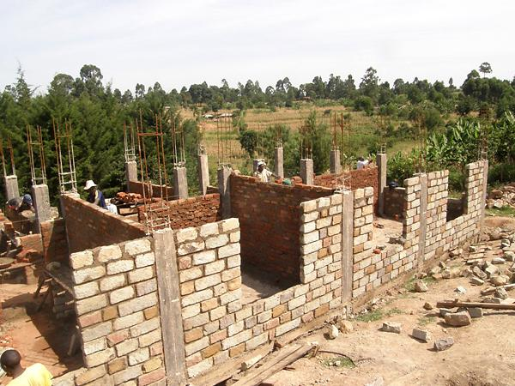Under this division, Axpex is able to undertake the construction of different types of buildings ranging from industrial, commercial, institutional to residential projects. We offer services that address all aspects of a building work; be it new construction or rehabilitation, refurbishment and maintenance of existing buildings that makes the concerned buildings suitable for its intended use.

We have a flare in using a combination of blue economy technologies and a variety of materials to get this done like concreting, stones/bricks walls, use of epoxy, glass and even wood.

Office construction works in Migori

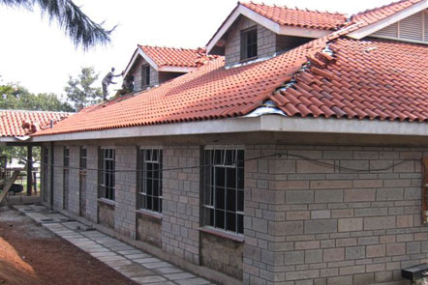

Roofing works in progress of a residential building

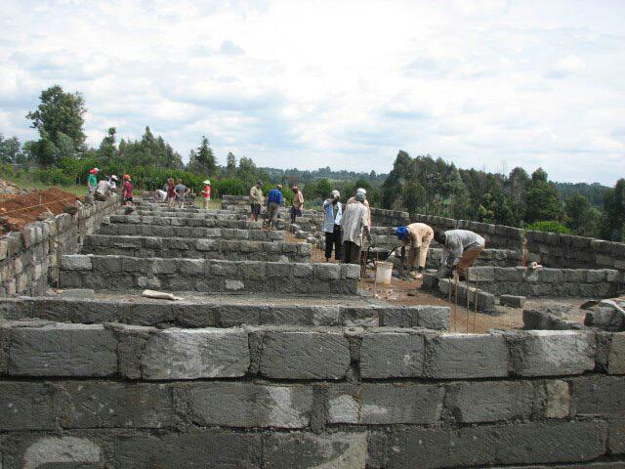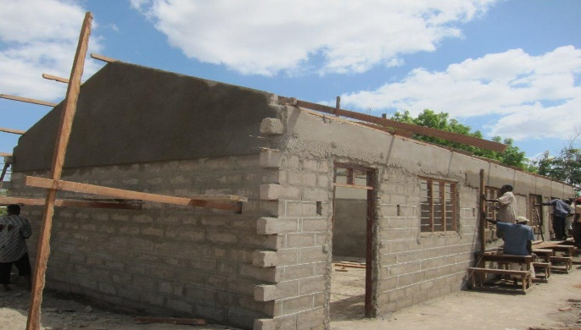

Classrooms building works in progress at different stages in Daho primary School

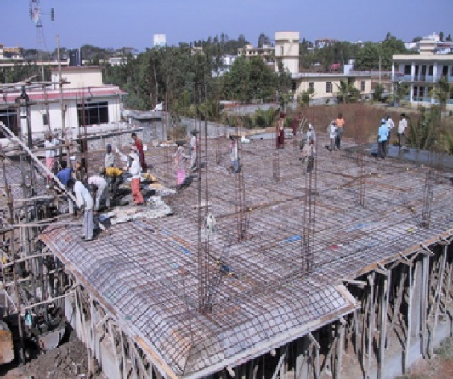

Commercial building/offices work in progress in Migori.

With collaborators, specialized building services like mechanical, electrical, electronics, telecommunications and air conditioning are offered.

1. **ROADS AND CIVIL ENGINEERING DIVISION**

Axpex is able to undertake all the making processes of different types of roads, drainages, bulk earth works, concrete works, large paved areas, bridges and piled foundations.

We also undertake specialized support civil engineering works for petrol stations, base stations, parking bays, go-downs and industrial complexes.

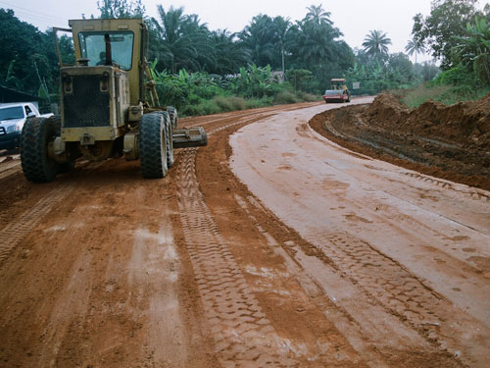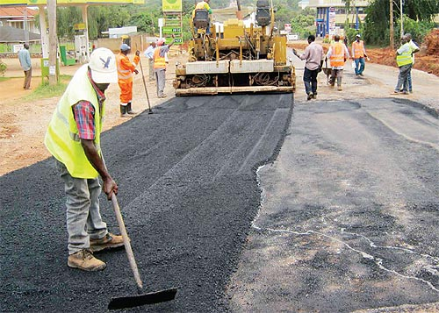

All weather road works in Kakamega County KURA road project in Ruaraka Industrial Estate

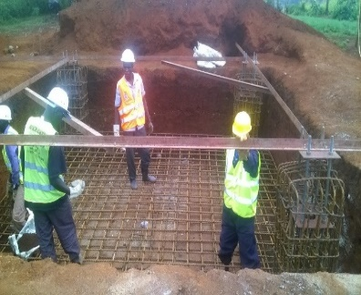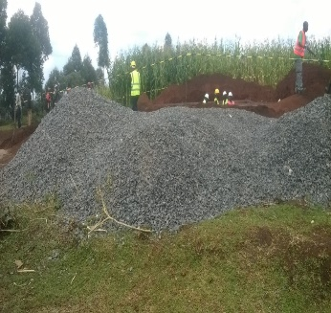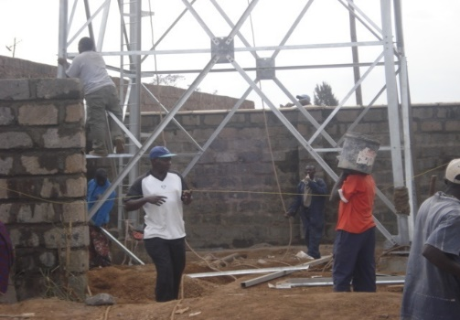

Base stations works in progress in Mandera

1. **WATER INFRASTRACTURE DIVISION**

Water is life. Axpex contributes to its availability by participating in its exploration, harvesting and distribution. In this section the company is able to undertake the design and construction of dams of all types, water reservoirs/pans, water plant intake sumps, portable water treatment plants, sewer treatment plants, water harvesting structures, overhead water tank structures, all types of irrigation schemes, drilling of wells/boreholes and water supply systems installation and expansion services.

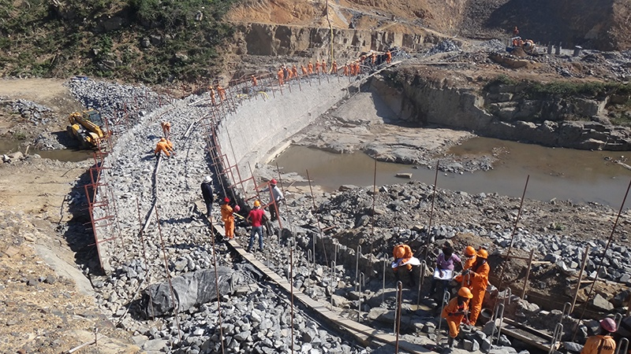We also offer dredging services to sump, pans and rivers.

Overhead water storage tanks against a beautiful blue skyline in urban Lagos, Nigeria
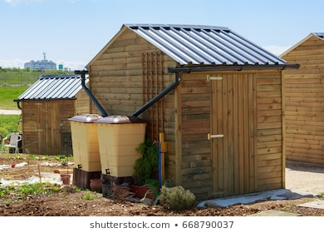

Overhead tank and rain gutters installation in Gem Concrete dam construction works in Bungoma

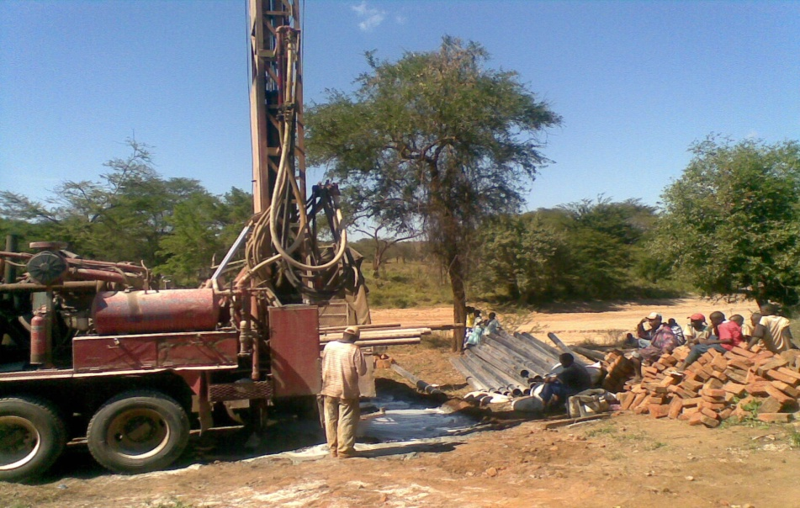 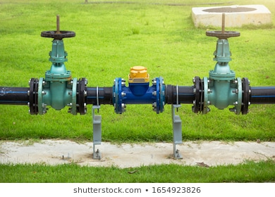

Borehole drilling and water piping network works for private client in Mua Hills – Machakos

1. **CONSULTANCY, DESIGN AND SUPPORT SERVICES UNIT**

**This division engages in consultancy, planning, design and management of projects within our products portfolios in case of need by the clients. These are normally done using the latest technologies and methods by our highly qualified and experienced technical staff.**

We also offer security systems installation services ranging from perimeter wall fencing, wire fencing, electric fencing, access control systems and security surveillance systems to remote-monitoring gadgets required in modern integrated commercial or residential estates and apartments.

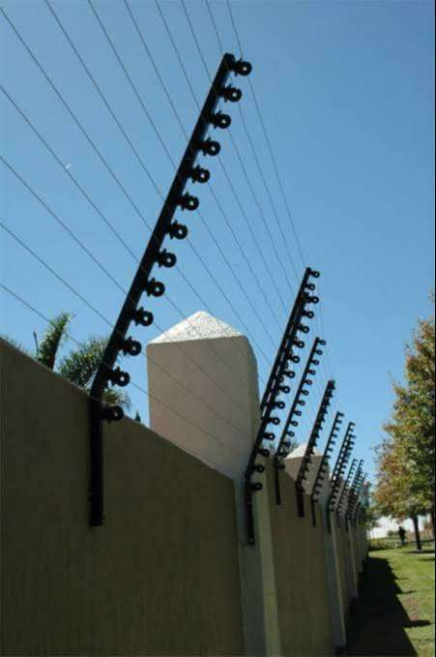 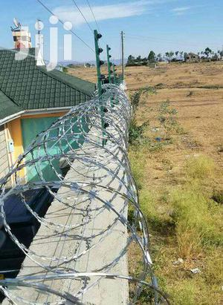

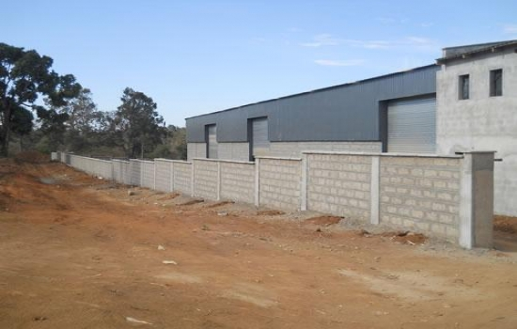 Nasra Estate project electrical fence wiring

Amref Health Africa perimeter wall and razor wire installation works

**OUR CONTACTS**

**SYNTRIX PLAZA, GROUND FLOOR, COURT 005,**

**RUARAKA INDUSTRIAL ESTATE,**

**JJ ROAD – OFF KUNDAN SINGH ROAD**

**NAIROBI – KENYA**

**P. O. BOX 7135 – 00300,**

**NAIROBI – KENYA**

**TEL. 254-(0)204401487**

**EMAIL ADDRESS:** [**axpexcons@gmail.com**](mailto:axpexcons@gmail.com) **&** [**info@axpexcon.com**](mailto:info@axpexcon.com)

**WEBSITE:** [**www.axpexcon.com**](http://www.axpexcon.com)